[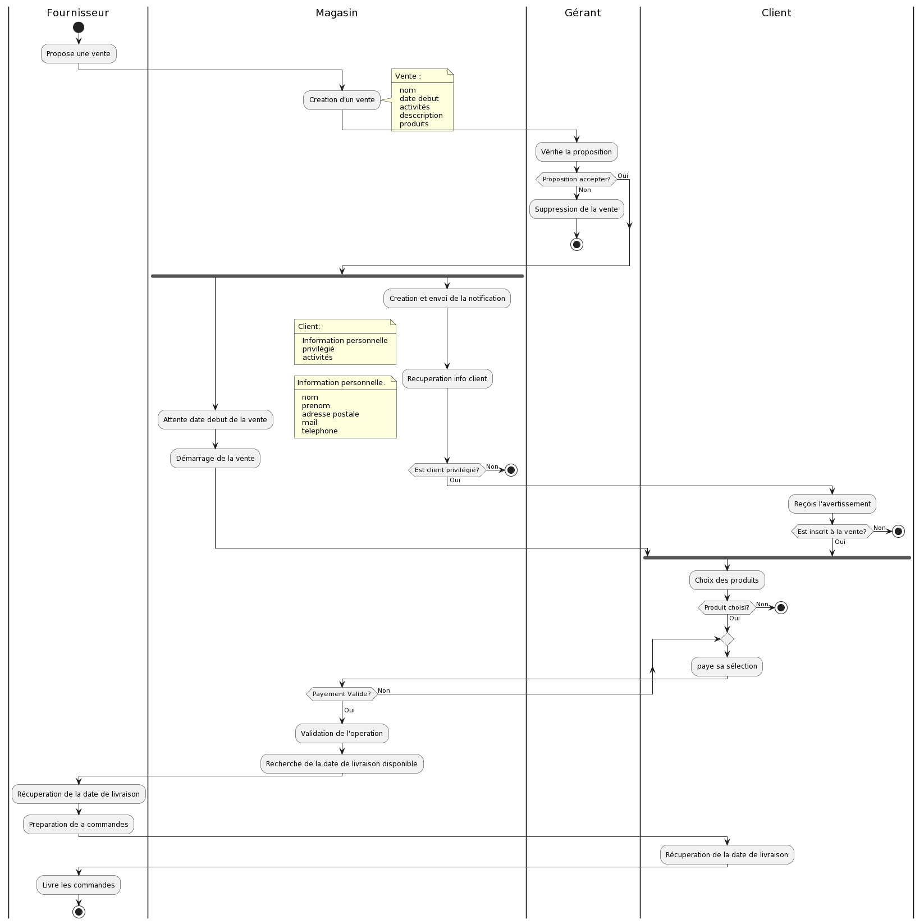](https://www.plantuml.com/plantuml/img/ZLHDhjem4Dxx5BC35ky2GMfLqHzLwWzwbTWRPo0Z7Dko7TedvJ3TLJb7BjQnam1vAXL8W9CPpyptOuSJ6IUzh2745utywqd5fjOYN29xgKv7RnjJAgkjX-Yb2Hn24qNxqJRUK0ZO-5Q4A7qKnTPRPmD2On3Ed8LhqNwLHnd8jABOU9IHh85oqPWfRcn4y7IieW3OfNTG02-V-CD_0CRMa1Ubv5Y9-oRcHwaYdIdsNHYY69Jov7A3_CPvMpOKWq1JGceZsazznn0YpxBZ5Hq8GSkKo5DJshaMT83bzlg2soXq4VtR5SGA3Io_DxGIg1dbyfirAsvrBGjG_6YSynX2nfdBZq21ARPkdQQXmmqj1-jFedWNOyP-1JdVNRplkrfwBuyu3xGRJPXwfph0HSdyatECWEPiQTpDV31y9GVGnJEgng4VKiaSBAXSTj27Pn-wp9Nvp7c-7lRmvc2DGQrn99_5qNrtfBvxBTT5Zx7sdJftRC3iydgeMIQc4LYiACV6jIIT5n4rkieQlFPBsdu8SSGsc_4_yivaczXcnle_bWBeXJoZZ-aWr9cmgGcPm7wCqF--gFLWapJlu8fDPUbNilR5p1U3fYTG70_qO5cFZhsGFEha2nzu2Q7lDAh10cpZYsi0XbpuMH5V3SijvoTmi9EQoWI3WKyjdju0zsKFvU1umDbZ2piPQdO9iDCgzFmTZJWQ7ZITlQIGDbDmrj1U9tVFRfdYkUzkV7gdm3hTGvXki2bBWh9rBGqJkRwLyB5ghsRumX6EioOtHJFFVm40)

[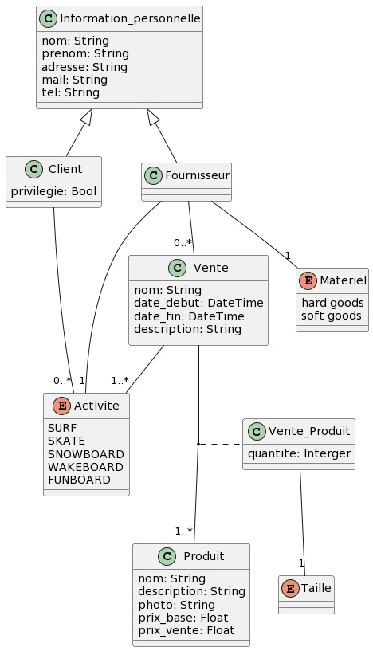](https://www.plantuml.com/plantuml/img/ZL9DRy8m3BtdLqISjccWxSffPL09eS74npXMWPfYAKsw94L8q_xxd9QMTbJJJh6VFvwVdHVhX75vAjb4vIaFzWvFw81_CSvNcsNedrcmdlXtljYE5i5oJFOsc4qgEzpCI_ERiRqKrlAfEcYJ2eTQHHaOgvK2ASkcIgT3ld86LK9UPg0DYDY0jT10Ke6ouJguUZNXgqHGZiFPWOh_viyC2PIG876Cj9RN9g7EZK8Ypyq_EjLbxqR7EReESJ7OlS7C5pSb7xNJhHNWETe9hpcKMhWAEf6Y6YEsuZvhMaQR_iEdHSqXFdEX7FhQAOLC0kPNTjUeWfh4iClTa8_9NcCA5Nn0rGOxP141-FdUACqWICzm52RcYTQn9SVgWxiub7kvLx_FUq-3mKEl_dUCDQ_Wuy-DO4Ui8ho9bNqBlOoLiekI0gxMTHEupj7UwuMjN3-xAuAFLPjxFcYVWVq0)